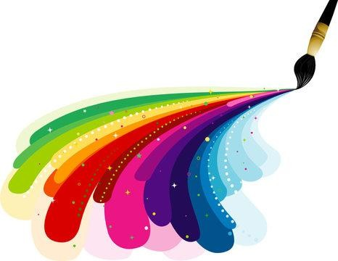
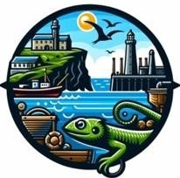
Coverack School

Lizard Schools Curriculum

Art Curriculum Overview
It is our intent that Art inspires, engages and challenges pupils; equipping them with the knowledge and skills to experiment, invent, create, develop and refine their own works of art, craft and design. The curriculum will offer all children the privilege of a broad developmental experience in both two- and three-dimensional art, together with the opportunities to enjoy, appreciate, discuss and critically respond to a variety of art, craft and design forms. The children will learn the necessary skills and build up an understanding of the way in which materials and media behave. The art curriculum will stimulate and enable all children to develop the confidence to explore and enjoy all of which the visual arts and its unique experiences have to offer and in doing so build on and develop skills which are essential to lifelong learning.

Significant Cornish Artists
 | EYFS / KS1 |  |  |  |  | KS2
Cycle 1 | Cycle 2 | Cycle 3 | Cycle 4 | Cycle 1 | Cycle 2 |  | Cycle 3 | Cycle 4
Alfred Wallis | Bernard Leach | Patrick Heron | Steve Camps | Bryan Pearce | Terry Frost |  | Ben Nicholson | Barbara Hepworth
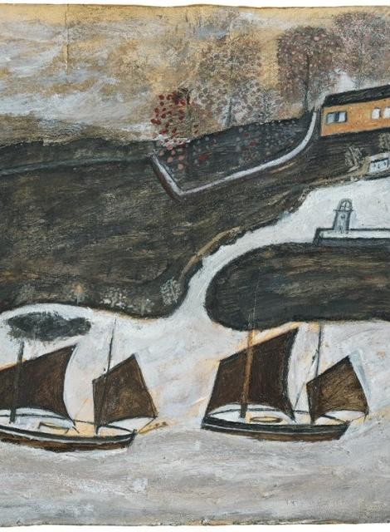 | 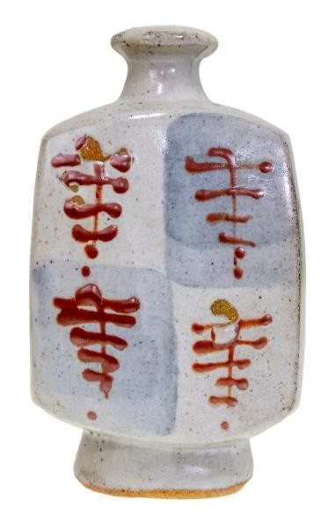 | 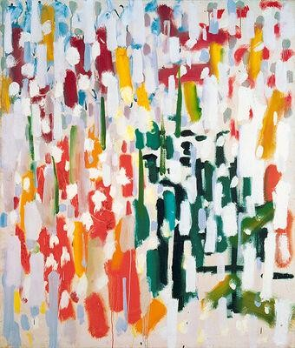 | 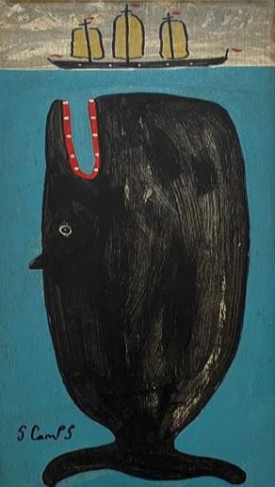 | 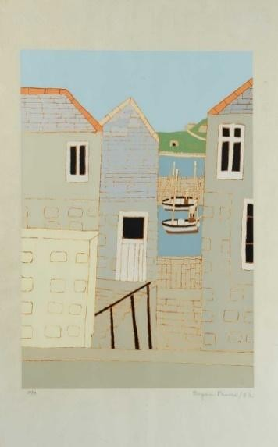 | 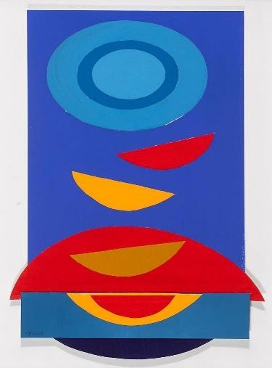 |  | 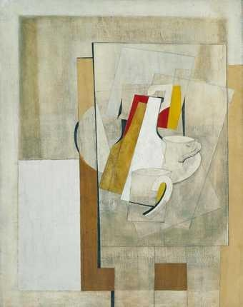 | 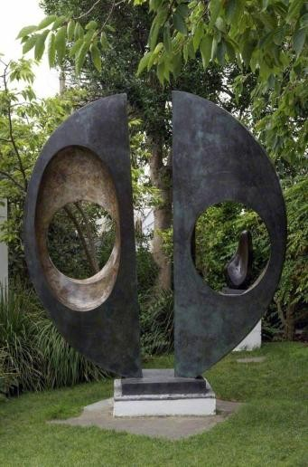

Key Artists

Piet Mondrian | Henri Matisse | Andy Warhol | Vincent van Gogh | Gustav Klimt | Henry Moore
Use of primary colours and line. | Use of vibrant colours and shapes. | Print, use of everyday materials. | Use of colour, tone and texture. | Use of pattern. | Use of form.
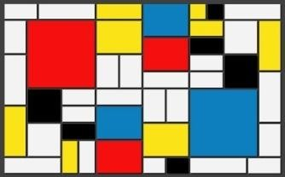 | 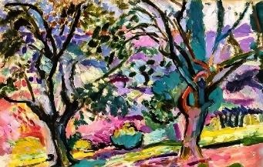 | 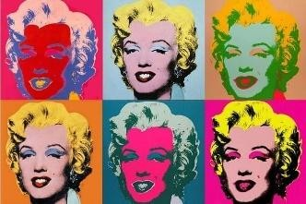 | 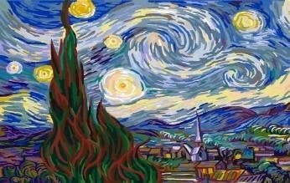 | 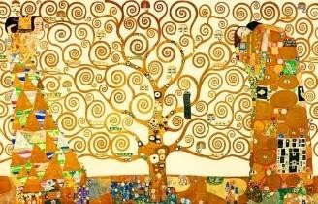 | 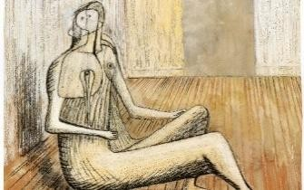
Alberto Giacometti | David Hockney | Keith Haring | Georgia O’Keefe | Wassily Kandinsky | Salvador Dali
Use of form. | Use of iPad and colour. | Line, shape and colour. | Natural, close up work. Use of colour. | Use of line, shape and colour. | Surrealism and technical skill.
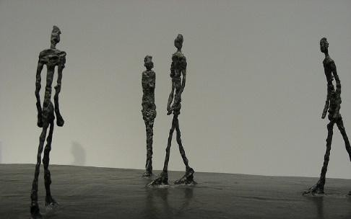 | 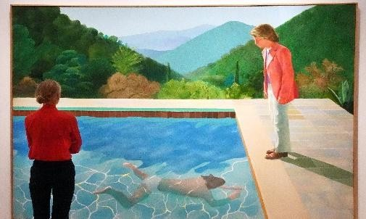 | 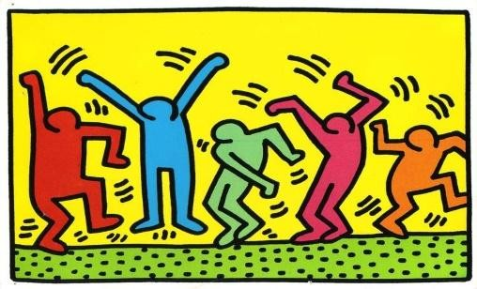 | 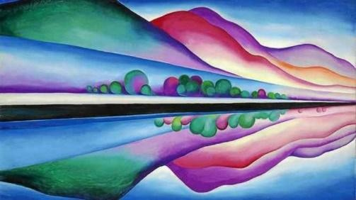 | 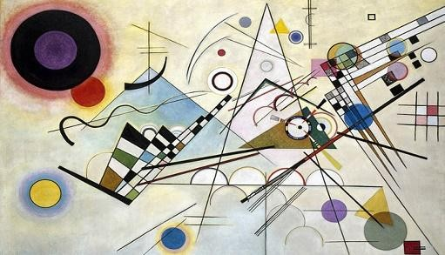 | 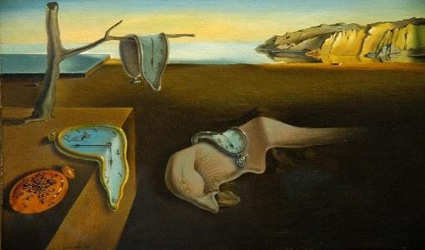

Curriculum Overview EYFS and KEY STAGE 1
EYFS/ KS1 | Autumn | Spring | Summer
Cycle 1 | Portrait inspired by Andy Warhol using natural and found objects- links to knowing the primary and secondary colours.  What makes a portrait effective or appealing? | Collage / silhouette – great fire of London scene  (focused on shadows and use of colour). Style of Mondrian (primary colours and line).  How can presenting art help us understand it?  Step 1: What materials can you use to create different textures?  Step 2: How do different colours affect our feelings?  Step 3: What stories can silhouettes tell in art?  Step 4: How can different art elements be combined to enhance a scene?  Step 5: What makes a piece of art effective or ineffective? | Flowers painting inspired by Vincent Van Gough’s  ‘Sunflowers’, focus on the use of colour and shape.  How can I make a painting like Van Gogh's?
Cycle 1 |  |  | Step 1: Who is Van Gough and what are the primary colours you can see in 'Sunflowers'?  Step 2: How do different brush strokes change the painting's appearance?  Step 3: How do colours in a painting make you feel?  Step 4: What shapes can you find in the 'Sunflowers' painting?  Step 5: What new colours can you make by mixing primary colours?
Cycle 1 | Step 1: Who is Andy Warhol and what is distinctive about his art?  Step 2: What materials can be used in creating art?  Step 3: How do different materials affect the texture of art? Step 4: What can we learn from sketching and planning a portrait?  Step 5: How does repetition change the impact of an image?  Step 6: What makes a portrait effective or appealing?

 |  | Step 6: How can presenting art enhance understanding of it? | Step 6: How can you use your new skills to make a painting like Van Gogh's?
 | Key Artist Link: Andy Warhol | Key Artist Link: Piet Mondrian | Key Artist Link: Vincent Van Gough
 | Curriculum Link (History): Who am I? Where do I come from? | Curriculum Link (History): Who was to blame and who helped in the Great Fire of London? | Curriculum Link (Science): How can we identify different plants and trees?
Cycle 2 | Inspired by Alfred Wallis, paint onto texture/ natural objects to create an Autumn landscape piece of artwork.  How do different textures influence art creation? | Ocean collages.  What is a collage and how did Matisse use this technique?  Step 1: What is a collage and how did Matisse use this technique?  Step 2: How can we use colour to represent different elements of the ocean?  Step 3: What techniques can we use to make our paper look like ocean waves?  Step 4: What can we observe about the ocean that can inspire our art?  Step 5: How can different materials change the look and feel of our collage?  Step 6: What have we learned from looking at each other’s collages? | To create Haring inspired human body artwork – line, shape and colour.  How can we use the line, shape, and colour to express
Cycle 2 | Step 1: How do different textures affect the feel and look of a piece of art?  Step 2: Who is Alfred Wallis's and how is his use of textures distinctive in his artworks?  Step 3: How does the type of paint used affect the outcome on different textured surfaces?  Step 4: How can we incorporate Alfred Wallis’s style into our own landscape compositions?  Step 5: What challenges do natural surfaces present when creating artwork?  Step 6: How do different textures influence art creation?
Cycle 2 |  |  | emotion and movement in art, similar to Keith Harding's style?
Cycle 2 |  |  | Step 1: Who is Keith Haring and what is his artistic style?  Step 2: How do artists use lines to convey movement?  Step 3: How do shapes combine to form human figures?  Step 4: How does colour impact the emotion of an artwork?  Step 5: What story will your artwork tell through these elements?  Step 6: How can we use the line, shape, and colour to express emotion and movement in art, similar to Keith Harding's style?
Cycle 2 | Key Artist Link: Alfred Wallis | Key Artist Link: Henri Matisse | Key Artist Link: Keith Haring
Cycle 2 | Curriculum Link (Science): Seasonal Changes (Autumn) | Curriculum Link (Geography): How are we connected to the sea? | Curriculum Link (Science): How has my body changed since I was a baby?
Cycle 3 | Painting of where I come from- inspired by Alfred  Walis (paintings of where he came from using scrap materials to paint with).  How do our surroundings and the materials we use | Clay sculptures of animals.  How can we use clay to represent different animals inspired by the techniques and artistry of Bernard Leach?  Step 1: What makes a sculpture unique?  Step 2: How do shapes influence sculpture design?  Step 3: What considerations are important in designing a sculpture?  Step 4: What challenges do we face when sculpting animals?  Step 5: How do textures change a sculpture? | Weather based artwork, exploring colour (two contrasting pieces).  How can we use art to effectively communicate different
Cycle 3 |  |  | weather conditions and their associated emotions?
Cycle 3 |  |  | Step 1: What materials and techniques can we use to mimic the textures found in different weathers?  Step 2: How can we use pastels to effectively represent different weather conditions?  Step 3: How do different colours represent different emotional responses to weather?  Step 4: In what ways did Georgia O'Keeffe abstractly represent weather in her artworks?  Step 5: How can we choose and apply different art techniques to convey calm and stormy weather effectively?
Cycle 3 | influence our art?  Step 1: What can we learn about texture from different materials?  Step 2: How did Alfred Wallis's background influence his style? Step 3: What details are important when drawing from observation?  Step 4: How do different materials affect the outcome of our artwork?
 | Step 5: How can we transform a simple sketch into a detailed painting?  Step 6: How can we use art language to describe and evaluate paintings? | Step 6: How can we use clay to represent different animals inspired by the techniques and artistry of Bernard Leach? | Step 6: How effectively do our artworks communicate the intended weather conditions?
 | Key Artist Link: Alfred Wallis | Key Artist Link: Bernard Leech | Key Artist Link: Georgia O’Keefe
 | Curriculum Link (History): Who am I? Where do I come from? | Curriculum Link (Science): How are living things adapted to their habitat? | Curriculum Link (Science): How does weather affect our lives?
Cycle 4 | Inspired by Alfred Wallis, paint onto texture/ natural objects to create a Winter landscape piece of artwork.  How does texture enhance the mood and feel of artwork? | Boat clay sculptures.  How can we create artistic boat sculptures in clay inspired by  Bernard Leach?  Step 1: Who is Bernard Leach and why is he important in the world of pottery?  Step 2: How can we design a clay boat that is both functional and artistic?  Step 3: What are the key properties of clay and how do these properties influence the techniques used in sculpture?  Step 4: What methods can we apply to begin forming our clay boats?  Step 5: How can different decorating techniques enhance the artistic expression of our clay boats?  Step 6: How do we assess our own work and what can we alter to improve the final sculpture? | Watery weavings.  How can we use weaving techniques and textures to
Cycle 4 |  |  | represent natural elements like water in textile art?
Cycle 4 | Step 1: How do different textures affect our perception of a landscape?  Step 2: How did Alfred Wallis use texture to express his artistic vision?  Step 3: What impact does the texture of the material have on painting techniques?  Step 4: How can texture be deliberately used in planning a piece of art to enhance its effect?  Step 5: How does preparing a textured base change the final artwork?  Step 6: How does the texture enhance the mood and feel of your finished winter landscape? |  | Step 1: What are the basic patterns used in weaving?  Step 2: How did Anni Albers convey emotions and concepts through her weavings?  Step 3: How do different materials affect the texture of a weave?  Step 4: How can we represent elements like water in our weavings?  Step 5: What techniques can we use to enhance the representation of water in our weave?  Step 6: How has our understanding of weaving grown through this project?
Cycle 4 | Key Artist Link: Alfred Wallis | Key Artist Link: Bernard Leech | Key Artist Link: Anni Albers
Cycle 4 | Curriculum Link (Science): Seasonal Changes (Winter) | Curriculum Link (Science): Which material is best for a boat? | Curriculum Link (Science): Seasonal changes (Summer)

KEY STAGE 2
KS2 | Autumn | Spring | Summer
Cycle 1 | Collage – Fish / Aquatic Life Vibrant colours & shapes.  How can we use the collage to capture the diverse | Pattern work - Viking Longships  How can the study of patterns from historical contexts and | Clay tiles – Olympians  How can we apply the artistic techniques of Angelous
Cycle 1 |  |  | Tsakirakis to create original Olympian-themed clay tiles?
Cycle 1 |  | prominent artists enhance our understanding and | Tsakirakis to create original Olympian-themed clay tiles?
Cycle 1 | characteristics of aquatic life, as inspired by Henri Matisse's art | prominent artists enhance our understanding and | Step 1: What characterises Tsakirakis's art style?  Step 2: How can Tsakirakis's style influence our tile designs?  Step 3: What are the essential techniques in clay sculpting?  Step 4: How can we ensure our tile reflects our initial design?
Cycle 1 |  | appreciation of art?  Step 1: What are the characteristics of patterns in Klimt's art and Viking longships?
Cycle 1 | style?  Step 1: How do colours and shapes evoke elements of aquatic life?

 | Step 2: What techniques did Matisse use to depict aquatic life?  Step 3: How can we use shape to represent different sea creatures?  Step 4: What materials best replicate the textures of aquatic life?  Step 5: How does refinement alter the impact of the collage? Step 6: What have we learned about Matisse’s style through our collages? | Step 2: How do colours and shapes influence the perception of patterns?  Step 3: What techniques can improve our pattern drawing skills?  Step 4: How can we effectively apply 2D patterns onto 3D forms?  Step 5: What criteria can we use to evaluate the effectiveness of a pattern in artwork?  Step 6: How can we effectively communicate our artistic choices to others? | Step 5: What finishing techniques best enhance our tiles? Step 6: How do our finished tiles reflect our learning and creativity?
 | Key Artist Link:  Henri Matisse | Key Artist Link:  Gustav Klimt | Key Artist Link:  Angelos Tsakirakis
 | Curriculum Link (History): How has fishing changed in Cornwall? | Curriculum Link (History): Why did the Vikings raid Britain? | Curriculum Link (History): Why did the Olympics originate in Greece?
Cycle 2 | Large scale cave painting (collaborative piece).  How have the Lascaux cave paintings influenced our | Propaganda posters – line, shape & colour.  How can we use line, shape, and colour to create a | Sculpture – soap carving.  How is sculpture influenced by nature and Barbara Hepworth's
Cycle 2 |  | compelling propaganda poster that communicates a
Cycle 2 | understanding of Stone Age life and art? | compelling propaganda poster that communicates a
Cycle 2 | understanding of Stone Age life and art? | powerful message?  Step 1: How does Keith Haring use line, shape, and colour to convey messages?  Step 2: What types of lines best convey urgency or calm in posters?  Step 3: How do different shapes affect the viewer's perception of a poster?  Step 4: How do colours influence the emotional response to propaganda posters?  Step 5: What techniques can enhance the message of a propaganda poster?  Step 6: How can art techniques be combined to maximise the impact of a propaganda poster?
Cycle 2 | Step 1: Why might these ancient people have created paintings inside caves?  Step 2: How do the materials used by Stone Age peoples influence the durability and texture of their art?  Step 3: What can the subjects of Lascaux paintings tell us about the life and environment of Stone Age people?  Step 4: What are the benefits and challenges of creating art as a group?  Step 5: How does using traditional methods and materials affect our artistic process and outcomes? Step 6: In what ways can reflecting on our artwork provide insights into both our creative and critical thinking processes? |  | methods?  Step 1: How does Barbara Hepworth's art reflect her interaction with nature?  Step 2: What makes an abstract form effective in sculpture? Step 3: Why is soap considered a good material for beginner sculptors?  Step 4: How do different tools impact the quality and detail of soap carving?  Step 5: What techniques enhance the texture and detail of a sculpture?  Step 6: How can we assess the effectiveness of our artistic choices in sculpture?
Cycle 2 | Key Artist Link:  Stone Age Art – Lascaux cave paintings | Key Artist Link: Keith Haring | Key Artist Link:  Barbara Hepworth
Cycle 2 | Curriculum Link (History): Why did settlements change from Stone Age to the Iron Age? | Curriculum Link (History): Why was the Battle of Britain a turning point in WW2? | Curriculum Link (Geography): Why do people visit St Ives?
Cycle 3 | Abstract Landscape Collage  How do colour, texture, and composition influence the mood | Borneo/forest paintings – Art Exhibition Display Project  How can the artistic exploration of Borneo’s forests deepen | Cornish Mine Silhouettes.  How can the techniques used by Henry Moore improve our
Cycle 3 | and interpretation of an abstract landscape? |  | understanding and appreciation of Cornish mining
Cycle 3 | Step 1: What distinguishes Georgia O'Keeffe's style in abstract landscapes?  Step 2: How do different colours communicate mood or atmosphere in an abstract landscape? |  | landscapes through art?  Step 1: How do different sketching techniques affect the portrayal of texture and depth?  Step 2: In what ways can form and structure communicate emotion or story?
Cycle 3 |  | our understanding and appreciation of the natural world?
Cycle 3 |  | Step 1: How do John Dyer’s artworks reflect his environmental concerns?
 | Step 3: How can textures affect the perception of depth and interest in a landscape?  Step 4: In what ways can we simplify natural landscapes into abstract forms while retaining their essence?  Step 5: What artistic decisions are most crucial when layering and combining different elements in a collage?  Step 6: How do the elements of our collages communicate our original intentions for an abstract landscape? | Step 2: What are the effects of different painting techniques on depicting natural textures?  Step 3: How do artists capture the complexity of a landscape in a sketch?  Step 4: How can layering enhance the depth and realism of a painting?  Step 5: How can art critique help improve our painting skills? Step 6: What considerations are important when curating an art exhibition? | Step 3: How does the use of negative space enhance the impact of a silhouette?  Step 4: What textures represent the Cornish landscape and how can these be effectively represented in art?  Step 5: How can 2D art be manipulated to give a 3D effect? Step 6: What have we learned from Henry Moore that influences our final artworks?
 | Key Artist Link:  Georgia O’Keeffe | Key Artist Link:  John Dyer – Last chance to paint | Key Artist Link:  Henry Moore
 | Curriculum Link (Geography): Why are mountains so important? | Curriculum Link (Geography): How is climate change affecting the world? | Curriculum Link (History): Who were the significant people in Cornish mining?
Cycle 4 | Fair Trade Posters (Warhol style).  How can the artistic style of Andy Warhol be utilised to | Pattern work – Animal Silhouettes.  How can understanding the pattern work and style of Gustav | Roman Soldier / Shield Mosaic  How can we use Roman mosaic techniques to create a
Cycle 4 |  | Klimt enhance our own artistic expressions in creating animal | piece of art that reflects both historical accuracy and
Cycle 4 |  | silhouettes?  Step 1: What are the key characteristics of patterns used in Gustav Klimt's artwork?  Step 2: How do Gustav Klimt's colour choices amplify the impact of his patterns?  Step 3: How can we effectively use patterns to enhance the visual impact of an animal silhouette?  Step 4: In what ways can different materials influence the appearance of patterns in artwork?  Step 5: What improvements can be made to more closely align our artwork with the style of Gustav Klimt? Step 6: How does sharing our artwork enhance our understanding and appreciation of Gustav Klimt's influence? | piece of art that reflects both historical accuracy and
Cycle 4 |  |  | personal expression?  Step 1: How do different mosaic techniques influence Roman artistry?  Step 2: What distinctive elements can we identify in Laurel True’s mosaics and their cultural significance?  Step 3: How can Roman themes be creatively incorporated into mosaic designs?  Step 4: What role does tessellation play in the visual impact of a mosaic?  Step 5: How do material choices affect the artistic and practical outcomes of a mosaic?  Step 6: What criteria can be used to effectively evaluate a mosaic artwork?
Cycle 4 | promote Fair Trade, and what impact can this have on viewer
Cycle 4 | perception and awareness?  Step 1: What is Fair Trade and why is it important?  Step 2: How did Andy Warhol influence the art world? Step 3: How can Warhol's style be adapted for a modern cause like Fair Trade?  Step 4: What artistic techniques can we learn from Warhol?  Step 5: How does colour impact the message of an artwork?  Step 6: How does our artwork communicate its message?
Cycle 4 | Key Artist Link:  Andy Warhol | Key Artist Link:  Gustav Klimt | Key Artist Link:  Laurel True / Emma Briggs
Cycle 4 | Curriculum Link (Geography): Why is fair trade fair? | Curriculum Link (Science): What animal am I most like? | Curriculum Link (History): How did the Romans impact Britain?

SKILLS and VOCABULARY PROGRESSION:

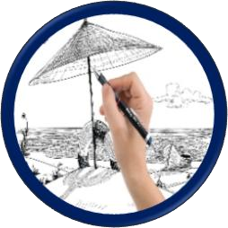

Drawing: Skills & Vocabulary
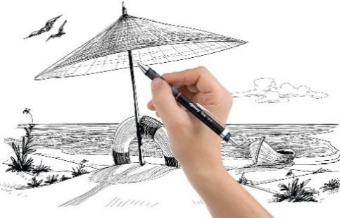 | DRAWING TOOLS – pencils, graphite, charcoal, watercolour, oil pastels, chalk pastels, handwriting pens, pens, biros, wax crayons, colouring pencils, ink, creation of own drawing tools such as attaching tools to long handles, taping numerous tools together to create a really chunky tool, use of sticks and pipettes with ink etc.  DRAWING SURFACES – drawing/cartridge paper, sugar paper, newsprint, lining paper, old envelopes, cardboard, ‘mathematical’ papers such as squared and graph, tracing paper, blotting paper, white boards, chalk boards, cardboard boxes, transparency sheets, creation of own drawing surfaces such as collaged or ‘mod roc’.  OBJECTS TO DRAW –  NATURAL – shells, pebbles, sticks, leaves, feathers, seeds, seaweed, flowers, fruit, vegetables, plants.  MAN MADE – blocks, cutlery, keys, cups/mugs, vases, tools such as screwdrivers, hammers, folded paper, shoes, buttons/beads, pencil sharpeners, cracker toys.  USEFUL ARTISTS  Degas, Escher, Holbein, Toulouse –Lautrec, Picasso, Durer, Seurat, Klee, Calder, Moore, Da Vinci, Senbanjo, Haring.

EYFS | Key Stage 1 | Lower Key Stage 2 | Upper Key Stage 2
- Explore making marks in/on different  surfaces e.g. glitter trays, paint, lentils, rice, sand, shaving foam etc.  - Explore different scales of mark making.  - Explore a wide variety of mark making tools including fingers and hands.  - Explore mark making on a variety of surfaces.  - Explore creating different thicknesses of line.  - Explore creating different types of line.  - Look at how shapes are formed (the joining of a continuous line).  - Begin to use shapes to represent objects.  - Start to draw marks that reflect patterns and textures.  - Start to create marks varying in tone – pressing on lightly and heavily.  - Make drawings with increased complexity and detail making such drawings become more symbolic.  - Encourage drawing from variety of experiences such as observation, memory, ideas (like movement or noise), feelings, emotions and imagination. | - • • •  •  - •  - •  •  - •  - •  • | Continue to use a variety of drawing tools.  Draw on different scales.  Draw on different surfaces.  Demonstrate increased control of drawing tools.  Explore different sorts of line and how they are produced with different tools.  Explore lines and shapes when drawing. Look at how marks can create different textures.  To continue to explore tone – light and dark. Make observational drawings of man-made objects.  Make observational drawing of natural objects.  Create drawings of their own choice. Create drawings from memory and experiences.  Create drawings using their imagination. Encourage use of more than one type of drawing tool when mark making.  Use art journal to record exploration, ideas and plans. | - • •  •  •  •  - • • • •  - • •  •  • | Continue to use a variety of drawing tools.  Use more than one type of drawing tool when drawing. Encourage children to alter their drawing surface e.g. by creating a ‘marked’ background, crunching up paper and then flattening etc.  Encourage use of different ways of drawing e.g. use of a continuous line, drawing subject in the time it takes to inhale and exhale one breath, drawing to music etc. (See AccessArt prompt cards for more ideas). Show awareness of textures, line, shape, and pattern when drawing.  Make observational drawings of objects (man-made and natural).  Create drawings from experiences and memories.  Create drawings using their imagination.  Develop use of tone in their drawings.  Begin to show awareness of 3 dimensions in drawings.  Use ‘artistic’ vocabulary when talking about drawings (the elements of art – line, shape, colour, tone, pattern, form, texture).  Create opportunities to develop imaginative drawings.  Carry out drawings of their own choice.  Annotate their work (process work), notes about materials used, likes and dislikes etc.  Use drawing as a way to communicate their thoughts and work through their ideas (use of the art journal as a practice/ideas/process book).  Use their art journal to explore and experiment with different media and techniques. | •  •  •  •  •  •  •  • • •  •  •  • | Continue to use and explore a variety of drawing tools and combine these e.g. use biro and graphite on the same piece of work.  Continue to explore and select a variety of backgrounds to draw on (surfaces and size).  Use the AccessArt prompt cards to encourage different ways of drawing.  Demonstrate more focus and concentration when drawing to produce drawings with detail.  Use and take into consideration the art elements of line, shape, tone, form, pattern, colour and texture when drawing. Use ‘artistic’ vocabulary when talking about drawings (the elements of art – line, shape, colour, tone, pattern, form, texture).  Make observational drawings of objects (man-made and natural).  Create drawings from experiences and memories.  Create drawings using their imagination.  Give opportunities for the children to record what they want using resources of their choosing.  Annotate their work (process work), add notes about tools, likes/dislikes, further ideas, thoughts, feelings etc.  Use drawing as a way to communicate their thoughts and work  through their ideas (use of the art journal as a practice/ideas/process book).  Use their art journal to explore and experiment with different media and techniques.
shape – circle, triangle, rectangle, square, big, small, etc.  line – thick, thin, long, short, straight, curvy etc. pattern  texture – rough, smooth, slippery, shiny, bumpy etc. colour – colour names.  mark making  tools and media - pencils, chalk, felt pens, crayons large / small imagine  observe/look at |  | drawing book sketch  practise  experiment explore  line – bold,  shape 2D, 3D pattern  form and space  texture and related words colour  tools and media – oil pastel, biro, charcoal |  | line  shape  pattern  texture  form tint  tone  cross hatching blend scale  surface develop ideas  colours – primary, secondary, complementary perspective horizon  background & foreground |  | highlight shadow  tools and media – ink, pipettes  organic shape  geometric shape  composition / form  perspective / focal point illustration  tone – grading of pencils (fine, hard, black) graphite  record annotate shade  atmosphere scale  proportion mixed media
Painting: Skills & Vocabulary 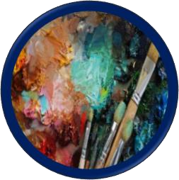

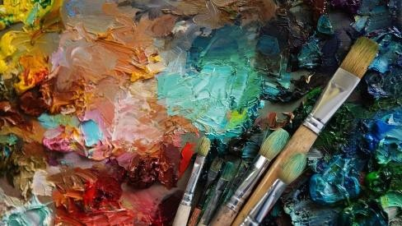 | PAINTING TOOLS – ready mixed paint, watercolour paint, acrylic paint, natural paints, brushes, palette knives, sticks, card, rollers, sponges, dabbers, scrapers, combs, toothbrushes, kitchen utensils, feathers, rags etc.  PAINTING SURFACES – paper, card, sugar paper, newspaper, book pages, sandpaper, board, clay, mod roc, greaseproof paper, tin foil, corrugated card, fabric, leaves, sticks etc.  USEFUL ARTISTS  Van Gogh, Cezanne, Picasso, O’Keefe, Kandinsky, Klee, Klimt, Monet, Rothko, Lowry, Magritte, Rembrandt, Pollock, Mondrian,

EYFS | Key Stage 1 | Lower Key Stage 2 | Upper Key Stage 2
- Enjoy using a variety of tools – brushes, sponges, fingers, twigs, rollers etc.  - Explore painting on different surfaces.  - Explore using surfaces and tools of different scales.  - Explore colours (as mixed by the teacher – ensuring differing ranges on offer at different times).  - Explore mixing of primary colours.  - Describe colours and marks.  - Paint on flat surfaces (e.g. paper, card, newspaper) and 3D surfaces (e.g. boxes, models, clay work). | - Continue to work with different tools on a variety of different surfaces and scales.  - Explore different marks that can be made with different painting tools.  - Develop control over use of tools and marks made.  - Begin to use drawing books as a way to test and experiment with paint and colour.  - Paint on flat (e.g. paper, pages, tinfoil, fabric) and 3D surfaces (e.g. boxes, clay work, sticks). | - Show understanding of colour when selecting and mixing colours for work.  - Use light and dark tones when painting.  - Explore complementary colours (R+G, Y+P, B+O).  - Explore use of more than one painting tool when creating a piece (e.g. different size brushes or using rollers and toothbrushes on the same piece).  - Use 2 surfaces (e.g. paper and newsprint )within a painting.  - Add a background colour wash to surface before working on top with other colours.  - Start to consider appropriateness of colours for different purposes.  - Show some independence when selecting tools and surfaces for own projects.  - Use a variety of vocabulary when talking about work. | - Continue to demonstrate their understanding of colour when painting.  - Show understanding of how to create tertiary colours.  - Show an understanding of the different sizes of brushes and the suitability for different purposes.  - Explore use of varying painting tools within a piece of work.  - Explore use of a variety of surfaces within a piece of work.  - Show growing confidence working with  different tools, paints on different surfaces/scales.  - Select appropriate resources for their work.  - Use appropriate vocabulary when discussing work.
light/lighter/lightest  dark/darker/darkest colour names  media and tools – paintbrushes, sponges, rollers, fingers, explore experiment | Primary – red, yellow, blue Secondary – green, orange, purple tone mix  explore  colour wheel control palette  paintbrushes – thick, thin, start to refer to different sizing practise  watercolour  background outline  drawing book | Warm colours – red, orange, yellow  Cool colours – blue, green purple  Complementary colours – red/green, yellow/purple, blue/orange tone  shade tint  bold  vibrant muted dull  mood stroke  landscape portrait  paintbrushes –refer to different sizing | hue – pure colour as found on colour wheel value – light colour has high value, dark colour has low value  vocabulary linked to type of colour e.g. sapphire, emerald, turquoise.  neutral colours – black white, brown, grey  acrylic
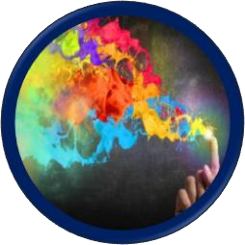
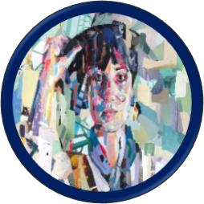
Colour: Skills & Vocabulary
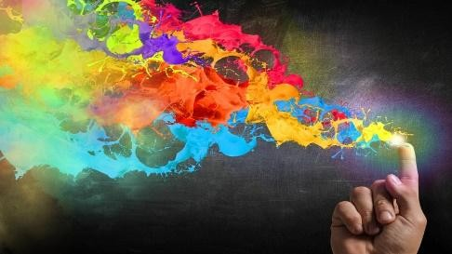 | To be developed in any of the areas of art e.g. paint, drawing, print etc.

 | EYFS |  | Key Stage 1 |  | Lower Key Stage 2 |  | Upper Key Stage 2
• • • •  • | Name colours.  Create collections of colour, colour sorting etc.  Name primary colours.  Recognise that there are light and dark tones of the same colour.  Know colours can be mixed to make new colours. | • •  •  • | Know the primary and secondary colours. Explore colour mixing and know how the secondary colours are created.  Recognise a colour wheel and show understanding of how it is made up. – Primary and secondary colours.  Recognise and mix different tones of a colour – adding white (a tint) and black ( a shade) to a colour. | • • •  • | Know what cool and warm colours are.  Know what complementary colours are. Develop further knowledge of the colour wheel and show understanding of how it is made up. – Primary and secondary colours, warm and cool colours, complementary colours.  Know that by adding white you create a tint and adding black you create a shade of the original colour. | •  • | Know what a tertiary colour is and how it is made.  Deepen understanding of a colour wheel. Primary and secondary colours, warm and cool colours, complementary colours, tertiary colours.

Collage: Skills & Vocabulary

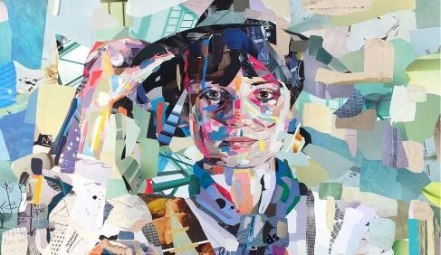 | COLLAGE TOOLS – wide variety of papers – wrapping, wall, magazines, paper bags, fabrics, glues, scissors, tapes, packaging, leaves, feathers, bark, netting, beads, buttons etc.  USEFUL ARTISTS  Pablo Picasso, Henri Matisse, Richard Hamilton, Peter Blake, David Hockey (photographic collages),Eileen Agar, Kurt Schwitters.

 | EYFS |  | Key Stage 1 |  | Lower Key Stage 2 |  | Upper Key Stage 2
• •  • | Use a stick glue and PVA glue.  Explore collage using precut papers, precut fabrics and embellishments.  Cut paper to use in a collage. | - •  - •  • | Cut paper and threads to use in collage.  Use fabric scissors to cut wool and strips of fabric into smaller pieces.  Use PVA glue to stick a variety of materials. Overlap, layer, arrange and rearrange collage pieces.  Explore collage using a combination of materials e.g. paper, fabric, wool, feathers, sequins etc. | •  •  •  • | Select own suitable materials to create collages.  Use fabric scissors to cut a variety of shapes and sizes of fabric for collages.  Create a variety of sizes and shapes of collage pieces to use with either/both paper and fabric.  Continue to explore embellishments within collage e.g. addition of glitter, feathers etc. to particular areas. | •  •  •  •  • | Explore collaging with paper they have changed the surface of e.g. printed on. Select, cut and stick varying materials to create collages.  Use shapes inspired by an environment or object to create a collage.  Use ‘other tools’ to add effects/extra details to a collage e.g. charcoal, pens, chalk, pastels etc.  Add stitching to a collage.
 |  |  |  |  |  | • | Use embellishments.

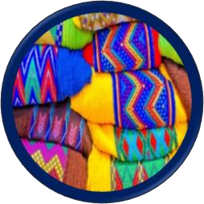
Textiles: Skills & Vocabulary

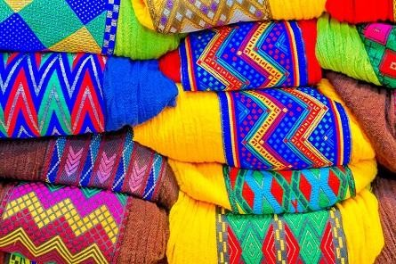 | TEXTILE TOOLS – variety of fabrics, threads, ribbons, wool, looms, fabric pens, fabric paints, embellishments such as sequins, buttons, beads, fabric dye, batik wax, tjanting, wax melting pot.  USEFUL ARTISTS  Kaffe Fassett, Charlotte Ashley, Maxine Bristow, African/Indian textiles, fashion designers, innovative textile artists – Sandra Chung Nga- Shan, Karen Dodd.

 | Nursery & EYFS |  | Key Stage 1 | Lower Key Stage 2 |  | Upper Key Stage 2
•  •  •  •  • | Enjoy handling, feeling and manipulating a variety of fabrics and textiles.  Start to build up an awareness of surface textures and the different qualities of fabrics/textiles. Enjoy collecting, sorting and playing with a wide variety of textiles and fabrics.  Explore weaving of different materials.  Start to build up vocabulary linked to textures. | •  •  - •  - • • • •  • | Enjoy and show awareness of the surface texture of fabrics and describe these.  Create rubbings of textured fabrics and talk about a visual texture.  Draw textures of fabrics using rubbings to help. Know what a stitch is, what it does and how it is made.  Create stitching on paper.  Create stitching on felt.  Explore creating stitches of different length.  Know what a loom is.  Explore weaving – use of different materials. Experience applying colour to fabrics- fabric crayons/pens. | - Explore the construction and destruction of materials to learn about qualities – woven and knitted fabrics.  - Practice knotting ribbons, wool and threads.  - Practice threading a needle.  - Create a running stitch with an even stitch length.  - Design and make a template for a sewing project.  - Use a running stitch to attach 2 pieces of fabric/felt together e.g. as in applique where one fabric is sewn to the surface of another fabric.  - Sew on buttons and beads.  - Explore paper weaving using a plain weave – know what the warp and weft threads are.  - Experience and explore tie-dye.  - Create dyes using natural materials e.g. onion skins, red cabbage. | •  •  • •  •  • | Weaving – set up a simple loom with warp threads.  Weave weft threads through warp to create the woven piece.  Design and create a print for fabric. Use a variety of stitches e.g. running stitch, cross stitch, over stitch, back stitch. Explore the effects of stitching and embellishments.  Explore and experience batik.
 | fabric  texture -soft, smooth, furry, bumpy, rough etc. feel  thread  needle stitch  decorate  weave -under, over collage  glue stick tear cut |  | texture  surface needle eye  fabric cloth  overlap layer  arrange  rearrange  fabric pens/crayons  apply  buttons beads  collage | natural fibres  synthetic fibres/man-made fibres ply  thread  cross stitch / back stitch running stitch fabric  construction / deconstruction  twisting / fraying  knotting / plaiting yarn  weaving / loom warp  weft  template  embellishment sequin  texture vocabulary – coarse, fine, glossy, matt  dye tie dye |  | natural fibres – cotton, wool, silk  synthetic fibres – nylon polyester  plain weave satin weave twill weave montage  assemblage overstitch  blanket stitch selvedge  design felt
colourfast / natural dye
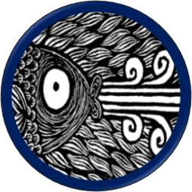
Print: Skills & Vocabulary

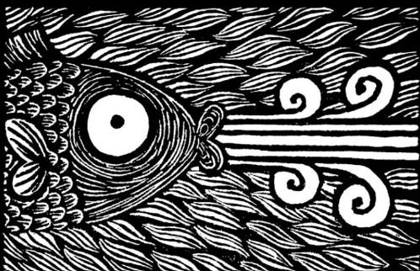 | PRINT TOOLS – rubbing plates, found natural/man-made objects, stencils, string, fruit/vegetable, relief prints, monoprints, block prints, brayer/roller, impressed printing.  USEFUL ARTISTS  Andy Warhol, Hokusai, William Morris, Roy Lichtenstein, Henri-de Toulouse-Lautrec, Mark Hearld.

 | Nursery & EYFS |  | Key Stage 1 |  | Lower Key Stage 2 |  | Upper Key Stage 2
•  •  • •  •  •  • | Rubbings – use a variety of objects to create rubbings.  Print using natural objects e.g. leaves, fruits and vegetables.  Print using man-made objects e.g. Lego, cars, corks. Stencils – enjoy the creation of a print using stencils – look at/discuss shapes used to create the pictures. Create pictures from printing – use of an object/s to create an image.  Create patterns.  Explore finger, hand and foot printing. | •  • •  •  •  • | Print using ‘found objects’ – natural and manmade, hard and soft materials.  Impressed print – using play dough/clay.  Identify objects that have printed images – books, comics, posters etc.  Create pictures from printing objects – use of different objects to portray different things in image.  Create patterns – random and repeat.  Explore string, tyre, sponge and roller printing. | • • • • • • • •  • | Identify and create a regular/repeat pattern.  Identify and create irregular/random patterns.  Create a simple monoprint – ‘butterfly ‘print.  Explore and create radial patterns.  Print using objects.  Design and create a polystyrene print plate.  Print with a polystyrene print plate.  Create work from printing-using the edges of cardboard – differing in length and thicknesses.  Create relief plate using card and foam shapes. | •  •  • •  • | Explore and create a variety of monoprints (a method where no two prints will be the same).  Design, create and print a relief plate suitable for a repeat pattern.  Explore carving into potatoes to create prints. Explore use of more than one colour when printing.  Design, create, and print an image suitable for a card.
rubbing  print -makes a copy  stencil  pattern  picture  finger, hand, foot |  | found objects  natural objects impressed print printed images patterns random repeat string tyre roller |  | print plate regular  irregular circular radial  mandalas  relief prints texture  print for purpose |  | monoprints relief plates  block print  impressed prints  polystyrene tiles etch  multiple colours  turn  rotate emboss

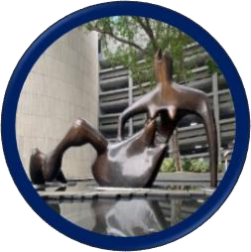
Sculpture: Skills & Vocabulary

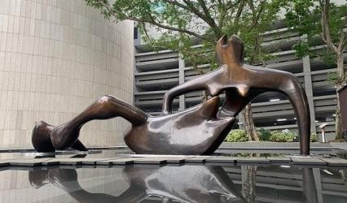 | SCULPTING TOOLS - clay, papier Mache, wire, pipe cleaners, plaster of Paris, mod roc, dough, paper, recycled objects, soap,  USEFUL ARTISTS  Barbara Hepworth, Henry Moore, Alberto Giacometti, Alexander Calder, Jeff Koons, Michelangelo, Andy Goldsworthy.

 | Nursery & EYFS |  | Key Stage 1 |  | Lower Key Stage 2 |  | Upper Key Stage 2
•  - • •  •  •  - • • | Explore a variety of 3D experiences, play and experiment with a range of tools and materials – build and take things apart. Talk about what they are doing.  Develop skills in relation to purpose, solve problems.  Talk, write, and draw ideas.  Manipulate and explore a range of malleable materials in a variety of ways e.g. rolling, kneading, joining, pinching etc.  Impress and apply decoration to a malleable material.  Experiment with constructing and joining recycled, natural and man-made materials.  Use masking tape to join materials.  Use glue to join materials.  Use scissors and tools safely. | - • •  •  - • • •  •  • | Know what a sculpture is.  Continue to experiment with malleable media. Manipulate malleable materials by e.g. rolling, kneading, and pinching.  Use tools and objects to apply different textures to malleable materials.  Apply finishes to sculptures e.g. paint.  Be aware of using tools and equipment safely.  Explore creating using recycled materials.  Explore use of different materials to attach objects together.  Use pipe cleaners, paper, card etc. to create forms.  Shape, form, construct and model from observation and imagination. | •  •  •  •  •  •  •  • | Work in a safe, organized way, caring for equipment.  Work with increased confidence with malleable materials – roll, shape, coil, create balls etc.  Construct a simple base for extending and modelling other shapes.  Develop techniques to join two parts  successfully. E.g. in clay score and slip,  Develop language appropriate to sculpting techniques and skills.  Start to develop ideas and from different sources.  Create drawings with annotations as a way to plan sculptural work.  Begin to adapt work as and when necessary and explain why. | •  •  •  •  •  • | Continue to model and develop work through a combination of methods e.g. in clay - roll, shape and join.  Gain experience in modelling over an armature e.g. newspaper frame for mod roc, papier-mache over wire.  Create drawings to develop and plan ideas, annotating these.  Explore carving (with soap), developing shapes and textures.  Explore line and shape using wire.  Adapt work and methods as necessary and be able to explain change of plans.
construction solid join  positional vocabulary such as on top, next to. 3 dimensional put together  take apart  malleable materials – roll, pinch, flatten, cut, cutter, knead  tools and media – materials, glue, tape, stick |  | clay  pinch roll  knead  impress shape form  model apply  recycled  construct  imagination observation change |  | malleable clay join slip  score  pressure  techniques adapt alter  source sculpt base extend |  | coil  slab  sculptural forms annotate armature  papier mache mod roc  carve wire  twist  shape bend loop  improve revisit


Response to Art: Skills & Vocabulary
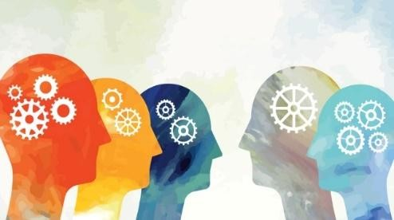 | To their own art, to peer art and work by famous artists, designers and craftspeople.  NB  Describe – can mean verbally and/or in the form of annotations alongside their work.  Annotation in creative journals should be encouraged from KS1 – even if this is just writing a few key words.

 | Nursery & EYFS |  | Key Stage 1 |  | Lower Key Stage 2 |  | Upper Key Stage 2
•  •  • | Talk about their own work, how they feel about it, how they created it etc.  Talking about likes and dislikes about a variety of art forms.  Describe varying art forms. | •  • • • •  • | Describe likes and dislikes of their work, work of their peers and others.  Describe their own art.  Describe art works by others.  Describe how they feel about their own work. Describe how they might change their piece if they were to do it again e.g. make it bigger, use different colours etc.  Start to use some of their newly acquired ‘art’ related vocabulary when describing their artwork and that of others e.g. use of different kind of marks, use of primary colours, use of textures etc. | •  •  - •  - •  • | Use more specific ‘art’ vocabulary when describing their art, work of their peers and others.  Describe how a piece of art makes them feel, why?  Describe how a piece of art looks.  Describe why they themselves/other artists have chosen to do things in a particular way e.g. to draw the eye to a particular area. Describe what they learned creating their art. Describe difficulties that arose and how they overcame these.  Describe how they may use their work to inform a new piece of art. | •  •  •  •  • | Describe choices they themselves as artists had to make whilst creating a piece and choices they think other artists had to make. Describe a piece of art to someone who has never seen it (Use art vocabulary).  Think about questions you would ask an artist to find out more about their work.  Think about/discuss titles of art pieces. Start to talk about art work in response to other pieces/artists they have seen.

Drawing Books: Skills & Vocabulary
 | Nursery & EYFS |  | Key Stage 1 |  | Lower Key Stage 2 |  | Upper Key Stage 2
• | Explorations through continuous provision. | • • • •  • | Record practice of skills.  Exploration of tools and materials. Exploration of colour  Information about artists.  Start some key word annotations. | • •  • | Bring in work from home to add. Writing annotations to go along with drawings, experimentations etc.  Use of journals to record trips, visits, outdoor experiences etc. | • •  • | Plan and develop ideas.  Own research into artists and areas of interest.  More annotations and notes whilst experimenting etc.
 |  |  |  |  |  | • | More thoughts on their own/others’ pieces.
 | draw  sketch record |  | practise try out  review like dislike |  | explore  experiment improve  make notes sources  of information adapt |  | annotate feelings  techniques adapt  compare style  influence message  feedback refine research

Meet Some Artists! | Tate Kids - useful link for children to explain some of the artists
Last Chance to Paint | environmental art project for schools – connecting children to the environment – online paint-along sessions
Downloads — Darrell Wakelam – Cardboard & junk modelling artist

