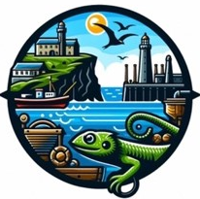
Coverack School
Lizard Schools Curriculum
Subject: Design Technology

We are committed to providing a curriculum that is underpinned by three essential drivers: aspiration, curiosity, and diversity. We aim to empower our learners to develop the knowledge, skills, and values they need to not only succeed in their education but also to become successful global citizens. Through our rigorously and consciously crafted curriculum, we teach clear sequences of enquiry-based learning encompassing the National Curriculum, reflecting the unique and special part of the world in which we live. We believe in helping our children flourish, realising their full potential, and fostering a caring and nurturing community where every child is valued.

Our Design Technology Concepts

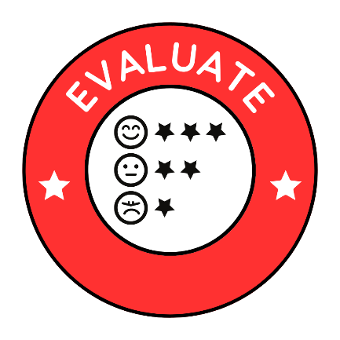
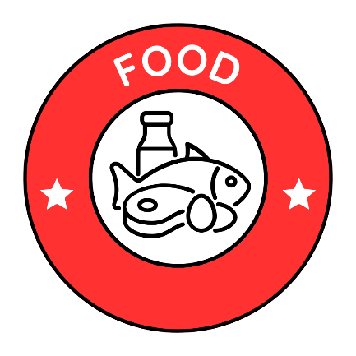
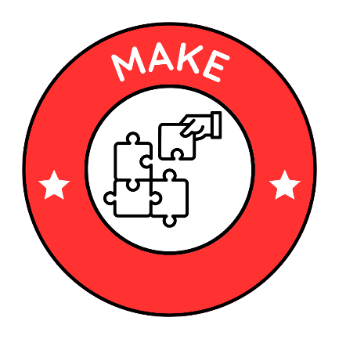
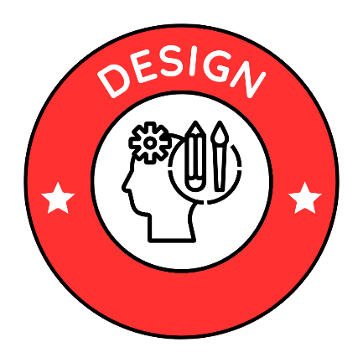

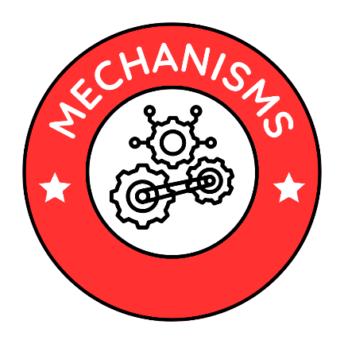
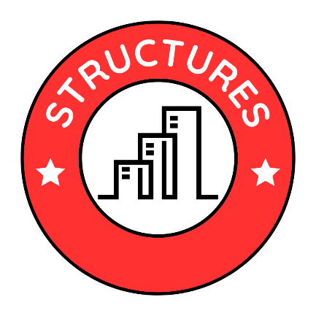

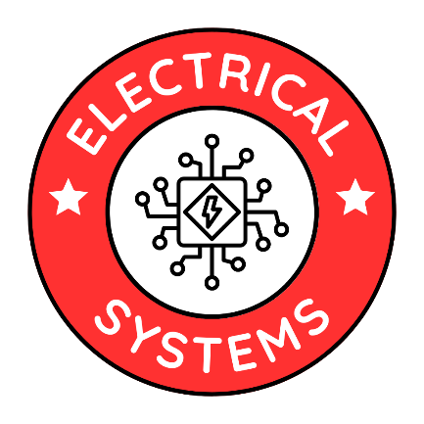

Curriculum Overview
KS1
Key Stage 1 CYCLE 1
AUTUMN | SPRING | SUMMER
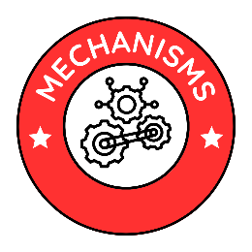  Mechanisms: Sliders and Levers  How can we make moving pages for Rosie’s Walk?  Lesson 1 – What existing products use sliders and levers?  Lesson 2 – How do sliders and levers work?  Lesson 3 – Can I design a moving page with a slider and lever?  Lesson 4 – Can I use my design to make a moving page with a slider and lever?  Lesson 5 – Is my final product successful? How do I know this? | 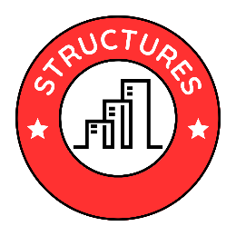  Structures: Freestanding structures  How can we make a strong, stable chair for The Tiger Who Came to Tea?  Lesson 1 – What is a freestanding structure? Where can I find these?  Lesson 2 – How do freestanding structures work?  Lesson 3 – Can I design a strong, stable chair for the tiger to sit on when he comes to tea?  Lesson 4 – Can I use my design to make a freestanding chair for the tiger?  Lesson 5 – Is my final product successful? How do I know this? | 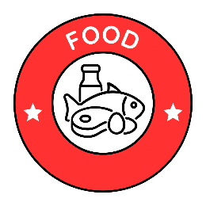  Food, Cooking and Nutrition  How can we make healthy snacks for our class picnic in the woods?  Lesson 1 – What do we have as our snack in school? Do we all like the same snacks?  Lesson 2 – Which foods are healthy? How much should we have in a snack?  Lesson 3 – Which kitchen tools will I need to use? How do I use these safely?  Lesson 4 – Can I design a healthy snack for our class picnic?  Lesson 5 – Can I use my design to make a healthy snack?  Lesson 6 – Is my final product successful? How do I know this?

Key Stage 1 CYCLE 2
AUTUMN | SPRING | SUMMER
Food, Cooking and Nutrition  How can we make a healthy bowl of soup for The Lighthouse Keeper?  Lesson 1 – What are our favourite soups? What do they taste like?  Lesson 2 – Which foods are healthy? Can all healthy foods go in a soup?  Lesson 3 – Which kitchen tools will I need to use? How do I use these safely?  Lesson 4 – Can I design a healthy soup for the Lighthouse Keeper?  Lesson 5 – Can I use my design to make a healthy bowl of soup?  Lesson 6 – Is my final product successful? How do I know this? | Mechanisms: Wheels and Axles  How do we make a trolley to take our tools to the garden?  Lesson 1 – What existing products use wheels and axels?  Lesson 2 – How do wheels and axels work?  Lesson 3 – Can I design a moving trolley with wheels and axels?  Lesson 4 – Can I use my design to make a moving trolley with wheels and axels?  Lesson 5 – Is my final product successful? How do I know this? | 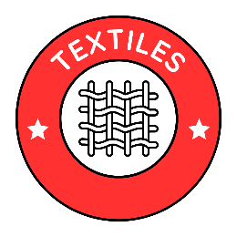  Textiles: Templates and Joining Techniques  How can we design and make a meerkat puppet for a class play?  Lesson 1 – Where can we find puppets? Are there different types of puppet?  Lesson 2 – How do templates and joins work?  Lesson 3 – Can I design a meerkat puppet using templates and joins?  Lesson 4 – Can I use my design to make a meerkat puppet?  Lesson 5 – Is my final product successful? How do I know this?

Curriculum Overview
KS2
Key Stage 2 CYCLE 1
AUTUMN | SPRING | SUMMER
Mechanisms: Levers and Linkages  How can we make a Christmas card with moving parts?  Lesson 1 – What existing Christmas cards have moving parts?  Lesson 2 – Which existing products are the most popular in our class?  Lesson 3 – How do levers and linkages work?  Lesson 4 – Can I design a Christmas card with moving parts?  Lesson 5 – Can I use my design to make a Christmas card with moving parts?  Lesson 6 – Is my final product successful? How do I know this? | Textiles : 2-D shape to 3-D product  How can we make a jewellery pouch for a trader or raider?  Lesson 1 – What is the function of a jewellery pouch? Are there different types?  Lesson 2 – Which existing products are the most popular in our class?  Lesson 3 – Which skills will I need to use to work with textiles?  Lesson 4 – Can I design a jewellery pouch using textiles?  Lesson 5 – Can I use my design to make a jewellery pouch using textiles?  Lesson 6 – Is my final product successful? How do I know this? | Food, Cooking and Nutrition  Gan Kernow! How can we make a traditional Cornish afternoon tea?  Lesson 1 – Which ingredients make a Cornish afternoon tea? What do these taste like?  Lesson 2 – Which types of scone are the most popular in our class?  Lesson 3 – Which kitchen utensils will I need to use? How do I use these safely?  Lesson 4 – Can I design a Cornish afternoon tea?  Lesson 5 – Can I use my design to make a Cornish afternoon tea?  Lesson 6 – Is my final product successful? How do I know this?

Key Stage 2 CYCLE 2
AUTUMN | SPRING | SUMMER
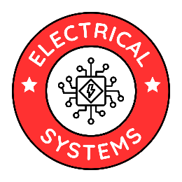  Electrical Systems: Simple Circuits and Switches  How can we make a night-light for family member?  Lesson 1 – What is a night light? Which types of night light are currently available?  Lesson 2 – Which existing products are the most popular in our class?  Lesson 3 – How do circuits and switches work?  Lesson 4 – Can I design a night light using a circuit and a switch?  Lesson 5 – Can I use my design to make a night light with a circuit and a switch?  Lesson 6 – Is my final product successful? How do I know this? | Food, Cooking and Nutrition  How can we make a healthy snack for a marathon runner?  Lesson 1 – Which foods are most suitable to release energy for runners during long distance runs?  Lesson 2 – Which existing products are the most popular in our class?  Lesson 3 – Which kitchen utensils will I need to use? How do I use these safely?  Lesson 4 – Can I design a healthy snack for a marathon runner?  Lesson 5 – Can I use my design to make a healthy snack for a marathon runner?  Lesson 6 – Is my final product successful? How do I know this? | Structures: Frame structures  How can we make a strong Bronze Age roundhouse?  Lesson 1 – What is a frame structure? Where can I find these?  Lesson 2 – How do frame structures work?  Lesson 3 – Can I design a strong Bronze Age roundhouse using a frame structure?  Lesson 4 – Can I use my design to make a strong Bronze Age roundhouse using a frame structure?  Lesson 5 – Is my final product successful? How do I know this?

Key Stage 2 CYCLE 3
AUTUMN | SPRING | SUMMER
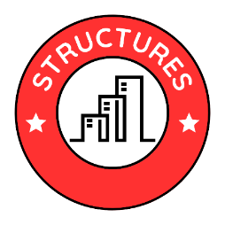  Structures: Shell structures (CAD)  How can we use CAD to design wrapping paper and packaging for a present?  Lesson 1 – What types of wrapping paper / packaging are currently on the market?  Lesson 2 – Which existing products are the most popular in our class?  Lesson 3 – How does CAD design work?  Lesson 4 – Can I design packaging for a present using CAD?  Lesson 5 – Can I use my design to make packaging for a present using CAD?  Lesson 6 – Is my final product successful? How do I know this? | Food, Cooking and Nutrition  How can we make a bread based lunch with a filling such as a wrap, sandwich, blini or toastie?  Lesson 1 – Which bread based lunches do we eat? What are the different ingredients?  Lesson 2 – Which existing products are the most popular in our class?  Lesson 3 – Which kitchen utensils will I need to use? How do I use these safely?  Lesson 4 – Can I design a bread based lunch?  Lesson 5 – Can I use my design to make a bread based lunch?  Lesson 6 – Is my final product successful? How do I know this? | Electrical systems: (micro:bits)  How can we make an alarm to alert us to invaders?  Lesson 1 – What is the purpose of an alarm? Where are these commonly used?  Lesson 2 – Which type of alarm would be most suitable when altering us of invaders?  Lesson 3 – How do micro:bits work?  Lesson 4 – Can I design an alarm using micro:bits?  Lesson 5 – Can I use my design to make an alarm using micro:bits?  Lesson 6 – Is my final product successful? How do I know this?

Key Stage 2 CYCLE 4
AUTUMN | SPRING | SUMMER
Food, Cooking and Nutrition  How can we make Fair Trade muffins or smoothies?  Lesson 1 – What does Fair Tade mean? Why is it important?  Lesson 2 – Which existing products are the most popular in our class?  Lesson 3 – Which kitchen utensils will I need to use? How do I use these safely?  Lesson 4 – Can I design a fair trade muffin?  Lesson 5 – Can I use my design to make a fair trade muffin?  Lesson 6 – Is my final product successful? How do I know this? | Textiles  Combining different fabric shapes (including CAD)  How can we make a belt for gardening tools?  Lesson 1 – What is the function of gardening belt? Are there different types?  Lesson 2 – Which existing products are the most popular in our class?  Lesson 3 – Which skills will I need to use to work with textiles?  Lesson 4 – Can I design a belt which holds different gardening tools?  Lesson 5 – Can I use my design to make a belt which holds different gardening tools?  Lesson 6 – Is my final product successful? How do I know this? | 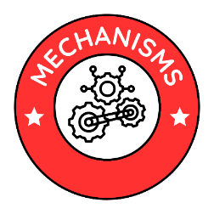  Mechanisms: Pulleys, gears or cams; pneumatics.  How can we make a catapult to hurl a .....?  History: Who were the Vikings and how did they live? 793 - 1050 AD  Lesson 1 – What is a catapult and how do they work?  Lesson 2 – Which existing products are the most popular in our class?  Lesson 3 – How do pulleys, gears and cams work?  Lesson 4 – Can I design a catapult with pulleys, gears and cams?  Lesson 5 – Can I use my design to make a catapult with pulleys, gears and cams?  Lesson 6 – Is my final product successful? How do I know this?

KS1 Skills  Coverage | Cycle 1  Autumn | Cycle 1  Spring | Cycle 1  Summer | Cycle 2  Autumn | Cycle 2  Spring | Cycle 2  Summer
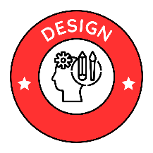
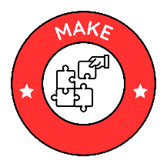
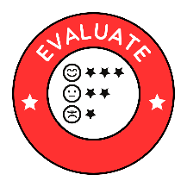
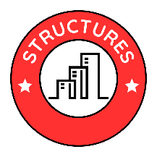 |  | 
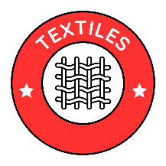
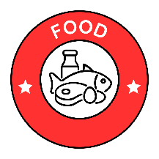
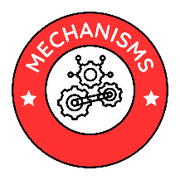
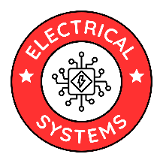

KS2 Skills  Coverage | Cycle 1  Autumn | Cycle 1  Spring | Cycle 1  Summer | Cycle 2  Autumn | Cycle 2  Spring | Cycle 2  Summer | Cycle 3  Autumn | Cycle 3  Spring | Cycle 4  Summer | Cycle 4  Autumn | Cycle 4  Spring | Cycle 4  Summer

